1. R Project -

Prepare a dataset related to your own project and perform k-Means, k-Medians, Expectation Maximisation (EM), Hierarchical Clustering and report the results.

Created an own dataset with the possible heart rate values:-

1. K-means clustering:

In our project, we analyze the heart beat data of the user collected and applied k-means algorithm on the data to get the clusters of heart rate. The corresponding R-code and graph are shown below:

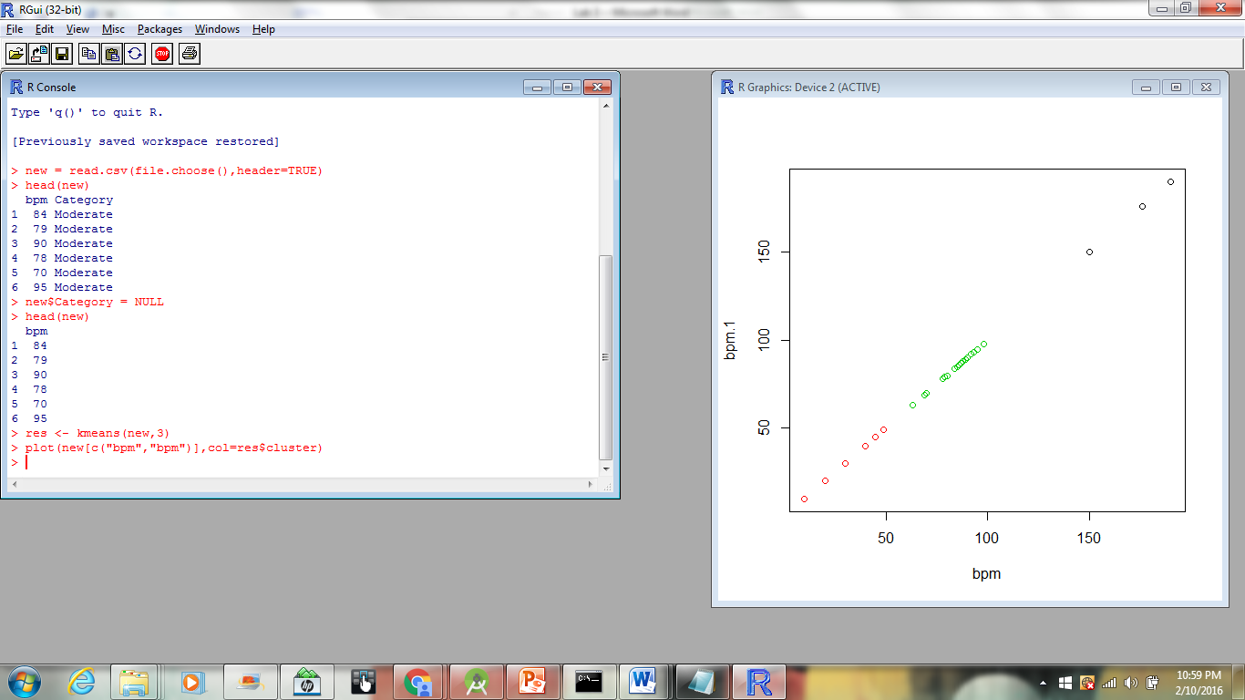

Hierarchical Clustering:

In hierarchial clustering, we are building an analysis of clustering, in which heart beat clusters are built in hierarchy. There are 2 types : agglomerative and divisive.

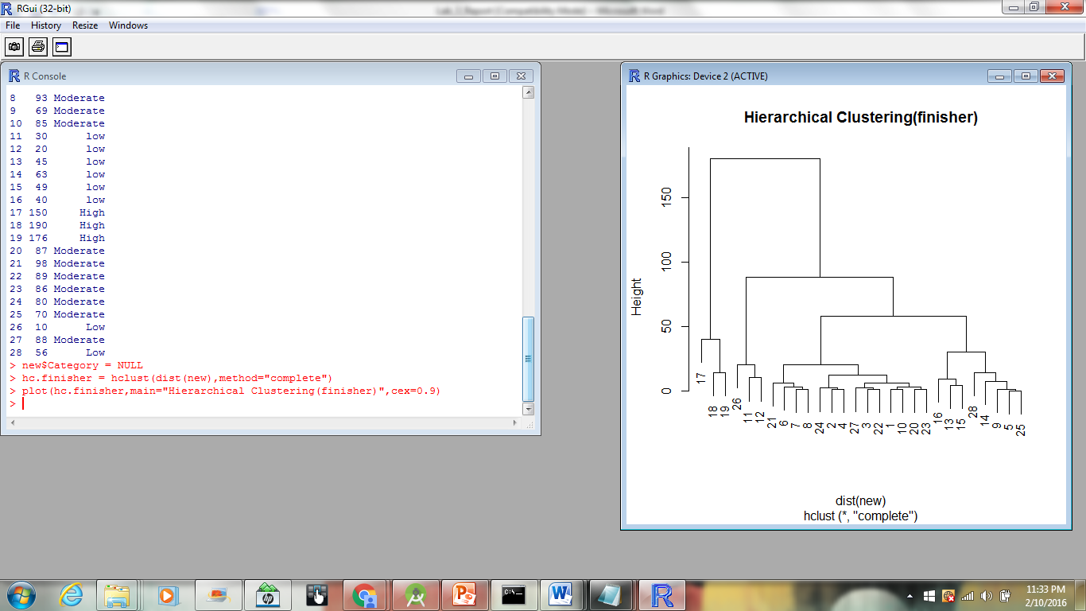

K-Medoids:

It is an algorithm which is related to both k-means and medoids. Both these algorithms aim at minimizing the distance between centroids. It’s a method in which n objects are divided into k-clusters.

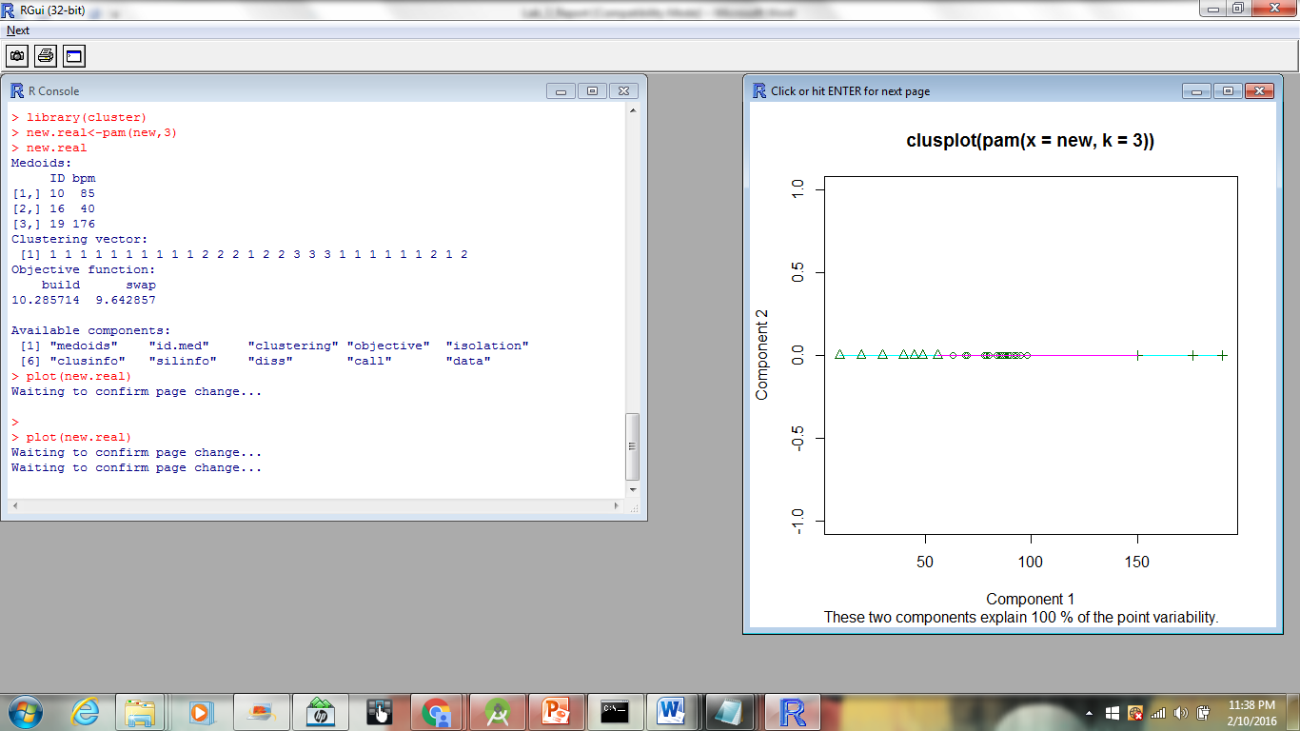

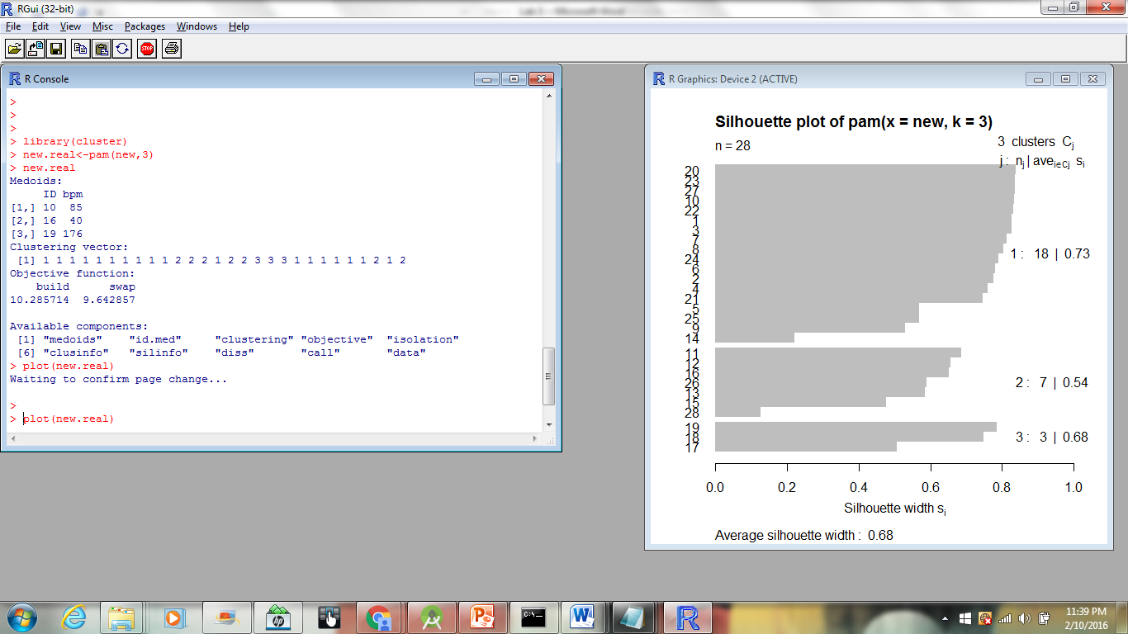

4. Expectation Maximisation:

It is an iterative method for finding maximum estimates of parameters in statistical models.  These parameter-estimates are then used to determine the distribution of the latent variables in the next E step.

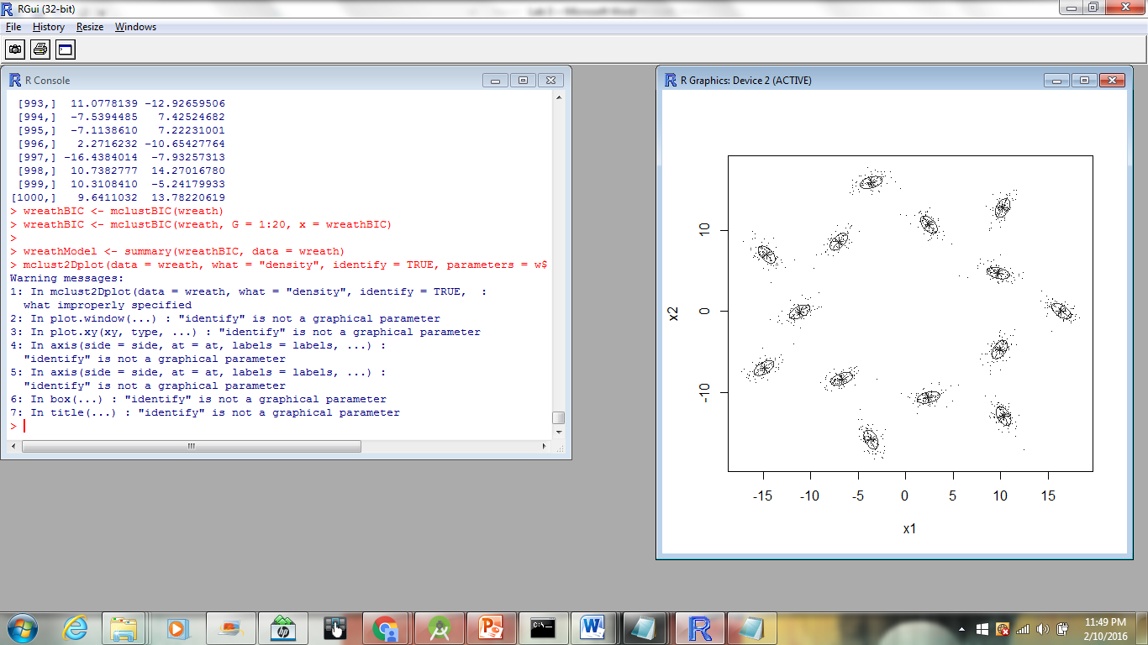

1. **Watch Application:**

Data collection related to your own project through Smart Phone and Watch, send notifications to watch using intuitive data analysis.

**Heart Rate Monitoring:**

In our project, we analyze the heart beat data of the user. So, we collected the heart rate data and steps walked.

Below is the screen shot taken after deploying the application and collecting the results.

